***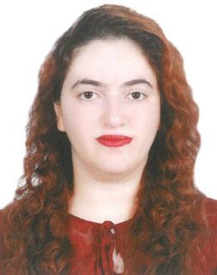*Curriculum Vitae**

***Personal Data:***

Name: Noor Mohammed AlMeerDate of Birth: 29th/April/1987Nationality: BahrainiCell: +973 66994699

Email: bulb853@gmail.com

***Education:***

Graduate: University of BahrainMajor/Degree: B.S in General Law

Marital Status: Single

***Languages:***

Arabic (Spoken and written)English (Spoken and written)

***Career Objectives:***

To work in a well-organized law firm with positive atmosphere that will give me the chance to show my skills.

* Department knowledge with Microsoft applications and Internet
* Dynamic and team player, consistently motivating toward success
* Communication and interpersonal skills, with ability to work under pressure and to deadlines

**Work Experience:**

April 2013 – Oct 2017 : Lawyer at Shaikh Hamad ben Abdullah Al Khalifa

law firm, handling all cases with court/

Agenda coordinator and consultant.

Feb 2013 – April 2013 Lawyer training at Mr. Rashed Al Jar law firm

Dec 2012 – Jan 2013 Lawyer training at Mrs. Reem Khalaf law firm

**Work Achievements:**

* Cultivated and tapped strong relationships with officials.
* Represented individuals and businesses in complex commercial, securities and consumer litigation.
* Defended individuals and businesses in criminal and regulatory investigations and prosecutions.
* Advise potential vendors concerning public bidding.
* Craft communications strategies to advance clients interests in public sector.

**References:**Available upon request